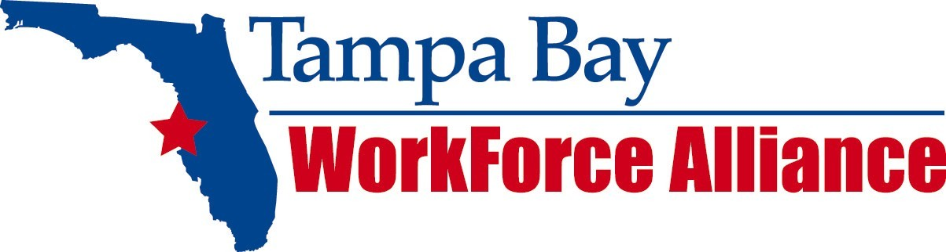

On-the-Job Training (OJT)

Application Kit 2010 - 2011

The Tampa Bay Workforce Alliance (TBWA) focuses on delivering employers innovative workforce solutions. The TBWA has both the resources and expertise to assist local employers who are seeking skilled employees to fill workforce vacancies. TBWA is committed to providing clients with all the services necessary to hire, train and retain the workforce they need.

On-the-job training (OJT) is one of the best training methods because it is planned, organized, and conducted at the employer’s worksite. OJT is one of the primary methods used for broadening employee skills and increasing productivity. It is particularly appropriate for developing proficiency skills unique to an employee's job - especially jobs that are relatively easy to learn and require specific equipment and facilities.

To apply, please complete the OJT Application Kit with the assistance of a Business Services Representative.

On-the-Job Training Program Overview

How does an employer benefit from the TBWA OJT Program?
The employer is reimbursed up to 50% of the candidate’s wages which goes to cover the costs of providing the training and additional supervision related to the training.

What types of jobs are eligible for OJT?
A full-time (32-40 hours per week) in any occupation paying $8.00 or greater. Wages must be paid to candidates that are the same as others performing a comparable job. Positions selected for OJT must be permanent and offer the potential for advancement. Positions that offer fringe benefits such as health insurance are preferred.

How long is the training period?
The length of the OJT is determined by the amount of time needed for the candidate to acquire the skills to perform the job for which they are being trained. During contract negotiation, TBWA will work with you to determine the length of training.

Who can participate in training?
OJT should be provided to individuals that lack the skills and experience required to qualify for your job opportunity. Through OJT, the individual will be prepared to meet basic job requirements for continued employment. All candidates must meet TBWA eligibility requirements. This process could take up to a week.

Can I enroll an employee in OJT after the individual has been hired or promoted to a new position?
No. You must complete the paperwork and receive approval of your application before you hire the employee. Please plan ahead.

How do I recruit individuals for the program?
As our client, you will collaborate with TBWA to identify and recruit candidates for the training program. If a recruiting agreement does not already exist, one will be created. OJT Job Order openings will then be posted in the TBWA job order systems. All candidates for training must be assessed by TBWA prior to hire to determine program eligibility. As always, the final decision on who is hired remains with you the client.

Is there anything else I should know?
You will be required to submit a job description and set up your training program during the contract training negotiation process. This will ensure that your program has all of the elements that it needs to be successful. Classroom training as part of the OJT program is permitted but must be pre-approved as a part of your program. You must establish a dedicated supervisor/mentor to the program. OJT Agreements are not allowed in cases where the candidate will work from home during the training period. You will be required to retain the candidate upon completion of the training program. Candidates participating in the OJT program cannot displace currently employed workers or results in a reduction of hours of non-overtime work, wages or employee benefits.

How do I get reimbursed?
The client will be reimbursed on a monthly basis upon the submission of completed progress reports, attendance records and an invoice for each OJT trainee. Multiple trainees can be listed on one submittal.

What documentation is required of OJT clients?
The client must retain and make available employment, time and attendance and payroll records for any candidate trained and hired under an OJT agreement throughout the training period. Periodic on-site monitoring of contracted OJT training will be conducted to assure that the program guidelines are followed.

I’m interested! What is the process?

- The business client determines the occupations to consider for OJT.
- A TBWA Business Services Representative assists with determining qualification for the program, completing the application, submitting Job Orders, identifying candidates, establishing training plans and timelines.
- The OJT Application is submitted.
- The business client collaborates with the TBWA staff to recruit and assess candidates for training.
- A contract agreement is created and signed.
- The candidate is hired and training begins.
- On or around the 30th of each month, fill out a progress report for each employee, and invoice TBWA for the contracted percentage of OJT wages.
- The candidate completes training and continues employment.

Please note:
Participating clients must be in compliance with all applicable federal, state, and local laws regarding employment (Fair Labor Standards Act, nondiscrimination, EEO, payment and reporting of wages earned work place safety, child labor and ADA). They must not be involved in any major labor disputes.

Part One: Company Profile

Company Name:
Contact Name & Title:

Address:
Phone: FAX:
E-mail Address: Website:
Product/Service:
Number of Employees: Federal Tax ID#:
Unemployment Insurance #:
Workers Comp. Carrier:
Policy #: Expiration Date:
Does your company offer health insurance? YES NO
What other benefits does your company offer full time employees?
Limited to 500 characters

Part Two: On-the-Job-Training Summary

Why is your company interested in developing an OJT Program?
Limited to 500 characters

Has your company previously conducted any training under federal, state or local workforce programs such as On-the-Job-Training, Incumbent Worker Training, Customized Training, etc.?

YES NO

Part Three: On-the-Job-Training Employer Eligibility

If any of the following questions are answered YES, the employer is not eligible.
YES NO
1. Is the client involved in a current major labor dispute? 2. Is the client in violation of local, state or federal labor laws?
3. Is the occupation seasonal or temporary?
4. Are current employees being dislocated or their hours reduced
as a result of this proposal?
5. Is the OJT training proposes for less than 32 hours per week?
6. Will the “employer of record” be an employment agency?

If any of the following questions are answered NO, the employer is not eligible.
YES NO
1. Will the client establish a dedicated supervisor for the program?
2. Is there an opportunity for career/financial advancement in the position?
3. Will the client retain the OJT candidates after completion of training?

4. Will candidates be provided the same fringe benefits and working

conditions as other employees?

5. Is the client willing to collaborate with TBWA representatives to hire
candidates and provide necessary information to run the program?

6. Is the client willing to provide the necessary information required and

abide by the terms of the program?
7. Is the client willing to place a job order in the system?
8. Does the client have the required Worker Comp. Insurance?
9. Can you offer at least $8.00 per hour?

Part Four: Job Descriptions

Please fill out the following form for each position that you wish to offer OJT.
Job Title: Turnover Rate: %
Hourly Wage Rate:$ Total No. of positions:

Detailed job description:
Limited to 500 characters

What are the minimum skills and/or work experience required for an individual to be considered for OJT in the position listed above?
Limited to 500 characters

What opportunities for advancement does your company offer an individual in this position?
Limited to 500 characters

What tools, uniforms, or other materials are necessary for the candidate to perform the job? Is the employee required to purchase these on their own? YES or NO
Limited to 500 characters

Please describe your current recruitment, methods, hiring procedures, and any pre-employment assessments required for this position.
Limited to 500 characters

Part Five: Plan of Study

Job Title: O*Net Job Title: To be filled by TBWA
Duration of Training: weeks Daily Hours Required:

Training Supervisor Contact Information

Training Supervisor: e-mail:
Telephone: FAX:
Training Location:

Training Outline

I. Learning Objectives
Describe Objectives to be learned

II. Materials required
List materials required for training

III. Training Outline
Week 1
Objectives to be learned
Week 2
Objectives to be learned
Week 3
Objectives to be learned
Week 4
Objectives to be learned
Week 5
Objectives to be learned
Week 6
Objectives to be learned
Week 7
Objectives to be learned
Week 8
Objectives to be learned
Week 9
Objectives to be learned
Week 10
Objectives to be learned
Week 11
Objectives to be learned
Week 12
Objectives to be learned

